A) HTML5 provides for 2 main validation options for form controls. Discuss them both providing HTML examples. [10 marks]

The two main validations options in HTML 5 are <input> and <required>. <required> means that an input box on the browser must not be left empty, there are different browser specific ways to let the user know whether they have entered in the data correctly or not. In Firefox for example this is shown by a red shadow around the box where the user is meant to enter in data. An example of this would be something like this: <input type ="text" address = "address" required>. Required can be used for other things as well but primarily it is used for the input type of "text". Speaking of input there are multiple types of input in HTML5 that are the other way of validating forms. Examples of these include: email, number, and date. These make sure that the user inputs data in a certain way, for email as an example it would be <input type = "email" name = "email"> and the user will need to enter in a email address in the format of "example@example.example" for all major current browsers

B) With the aid of diagrams compare and contrast HTML4 and HTML5 content models and explain why this model has become more complicated. [15 marks]

A content model is what defines how elements are used. HTML4 used only 2 main categories: inline and block level. HTML5 on the other hand has a load of different categories as seen below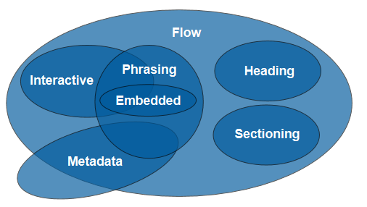

The reason why this has become so complicated is because there where many elements of HTML4 that didn't come down under these 2 main categories because it evolved past these. The HTML5 model tries to bring all these old elements and the new ones as well under new headings

C) With the aid of a diagram discuss how HTML forms work. Your answer should include discussion of HTTP methods and how data is formatted and encoded. [15 marks]

A form is a way of getting information from the user. There are many different types of form but the main one is the <input> element which has different sub-elements such as <input type = "text"> which allows the user to enter in text into a box or <input type = "radio"> which makes the user pick from a set amount of answers by button click. The data that the user inputs is sent to the server using "get" and "post" provided by HTTP but not before it is formatted in HTML by enctype. This allows for safe transfer from the user's webpage back to the main server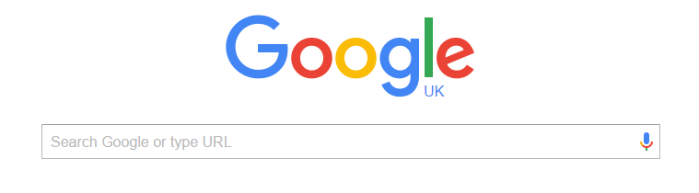

The above shows how the <input type = "text"> form is used, it is used in the search bar.

a) The diagram below shows a page layout using an HTML4 approach. Redraw it using HTML5 semantic elements and discuss why this is a better approach. [10 marks]

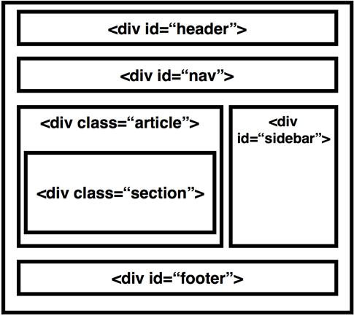

In HTML this is how it would look:

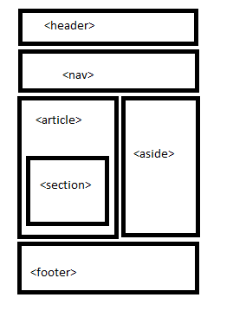

In HTML4 divs where merely separators for different parts of HTML code but in HTML5 these are instead known as sections, and they have actual names now instead of user defined names. A div has no actual meaning while sections such as <header> and <footer> have actual meaning behind them. This is a better approach because this allows the maker of the website group things easier while before the creator had to create their own groupings and there was no actual set in stone standard to naming your divs. This makes it easier for when a website is passed over for someone else to work on because in the HTML4 days a creator could name their divs something completely different to how someone else would name them